Practice Free Response Questions

1. Represented below are five identical balloons, each filled to the same volume at 25ºC
and 1.0 atmosphere pressure with the pure gases indicated.

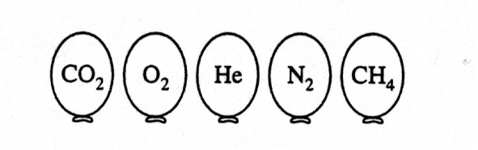

- Which balloon contains the greatest mass of gas? Explain.

- Compare the average kinetic energies of the gas molecules in the balloons. Explain.

- Which balloon contains the gas that would be expected to deviate most from the behavior of an ideal gas? Explain.

- Twelve hours after being filled, all the balloons have decreased in size. Predict which balloon will be the smallest. Explain your reasoning.

2. A rigid 5.00 L cylinder contains 24.5 g of N₂(g) and 28.0 g of O₂(g)

(a) Calculate the total pressure, in atm, of the gas mixture in the cylinder at 298 K.

(b) The temperature of the gas mixture in the cylinder is decreased to 280 K. Calculate each
of the following.

i) The mole fraction of N₂(g) in the cylinder.

ii) The partial pressure, in atm, of N₂(g) in the cylinder.

- If the cylinder develops a pinhole-sized leak and some of the gaseous mixture escapes, would the ratio of moles of N₂(g) to moles of O₂(g) in the cylinder increase, decrease, or remain the same? Justify your answer.

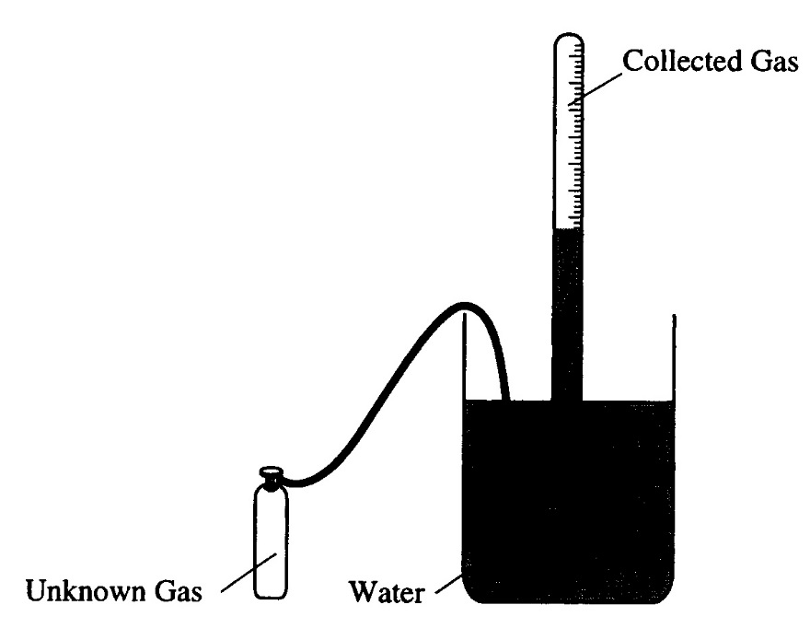

3. A student performs an experiment to determine the molar mass of an unknown gas. A small amount of the pure gas is released from a pressurized container and collected in a graduated tube over water at room temperature, as shown in the diagram above. The collection tube containing the gas is allowed to stand for several minutes, and its depth is adjusted until the water levels inside and outside the tube are the same. Assume that:
- the gas is not appreciably soluble in water
- the gas collected in the graduated tube and the water are in thermal equilibrium
- a barometer, a thermometer, an analytical balance, and a table of the equilibrium vapor pressure of water at various temperatures are also available.

- Write the equation(s) needed to calculate the molar mass of the gas.

- List the measurements that must be made in order to calculate the molar mass of the gas.

- Explain the purpose of equalizing the water levels inside and outside the gas collection tube.

- The student determines the molar mass of the gas to be 64 g mol⁻¹. Write the expression (set-up) for calculating the percent error in the experimental value, assuming that the unknown gas is butane (molar mass 58 g mol⁻¹). Calculations are not required.

- If the student fails to use information from the table of the equilibrium vapor pressures of water in the calculation, the calculated value for the molar mass of the unknown gas will be smaller than the actual value. Explain.

4. Explain each of the following in terms of atomic and molecular structures and/or intermolecular
forces.

- Solid K conducts an electric current, whereas solid KNO3 does not.

- The normal boiling point of CCl4 is 77°C, whereas that of CBr4 is 190°C.

- Iodine is a solid at room temperature while bromine is a liquid.

- Acetone, CH₃COCH₃, has a higher vapor pressure than enthanol, CH₃CH₂OH.

- Dry ice has a lower freezing point than water.

- Sodium chloride has a higher melting point than potassium chloride.

